Logistic Regression
Q1)
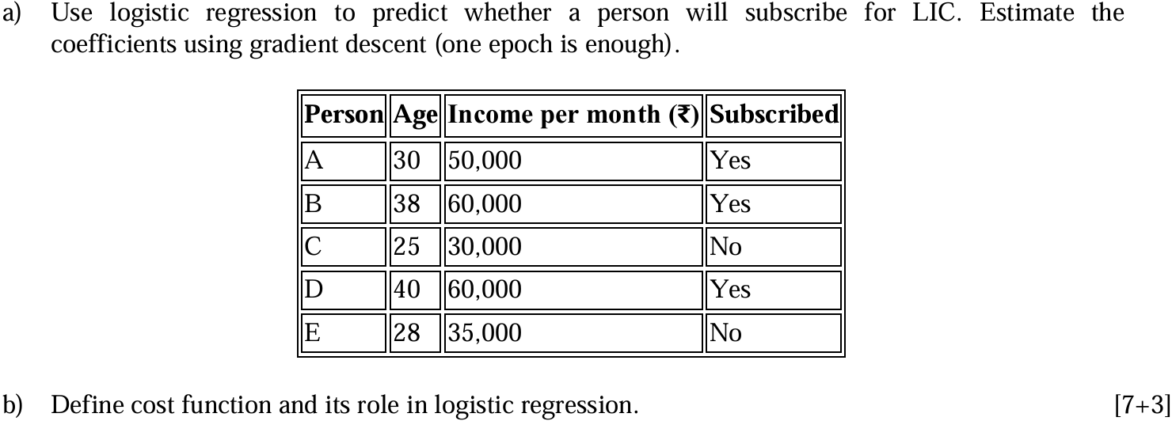

(a) Logistic Regression using Gradient Descent (One Epoch)

Step 1: Convert Class Labels
Person | Age | Income | Subscribed
A | 30 | 50000 | 1
B | 38 | 60000 | 1
C | 25 | 30000 | 0
D | 40 | 60000 | 1
E | 28 | 35000 | 0
Where:
- Yes = 1
- No = 0

Step 2: Logistic Regression Formula

Linear Model
$$z=w_{1}x_{1}+w_{2}x_{2}+b$$
Where:
- $x_{1}$= Age
- $x_{2}$= Income
- $w_{1},w_{2}$= weights
- $b$= bias

Sigmoid Function
$$σ(z)=\frac{1}{1+e^{-z}}$$

Step 3: Initialize Parameters
Assume initially:
$$w_{1}=0,w_{2}=0,b=0$$
Learning rate:
$$η=0.01$$

Step 4: Compute Predictions
Since all weights are zero:
$$z=0$$
Thus:
$$σ(0)=\frac{1}{1+e^{0}}=0.5$$
So predicted probability for every sample:
$$\hat{y}=0.5$$

Step 5: Compute Errors
$$Error=y-\hat{y}$$
Person | Actual $y$ | Predicted $\hat{y}$ | Error
A | 1 | 0.5 | 0.5
B | 1 | 0.5 | 0.5
C | 0 | 0.5 | -0.5
D | 1 | 0.5 | 0.5
E | 0 | 0.5 | -0.5

Step 6: Weight Update Formula
$$w_{j}:=w_{j}+η∑(y-\hat{y})x_{j}$$
Bias update:
$$b:=b+η∑(y-\hat{y})$$

Step 7: Update Weight for Age
$$∑(y-\hat{y})x_{1} \\ =(0.5)(30)+(0.5)(38)+(-0.5)(25)+(0.5)(40)+(-0.5)(28) \\ =15+19-12.5+20-14 \\ =27.5$$
Now:
$$w_{1}=0+0.01(27.5) \\ \boxed{w_{1}=0.275}$$

Step 8: Update Weight for Income
$$∑(y-\hat{y})x_{2} \\ =(0.5)(50000)+(0.5)(60000)+(-0.5)(30000)+(0.5)(60000)+(-0.5)(35000) \\ =25000+30000-15000+30000-17500 \\ =52500$$
Now:
$$w_{2}=0+0.01(52500) \\ \boxed{w_{2}=525}$$

Step 9: Update Bias
$$∑(y-\hat{y}) \\ =0.5+0.5-0.5+0.5-0.5 \\ =0.5$$
Thus:
$$b=0+0.01(0.5) \\ \boxed{b=0.005}$$

Final Updated Coefficients After One Epoch
Parameter | Updated Value
$$w_{1}$$ | 0.275
$$w_{2}$$ | 525
$$b$$ | 0.005

Final Conclusion
After one epoch of gradient descent, the logistic regression coefficients become:
$$\boxed{w_{1}=0.275,w_{2}=525,b=0.005}$$
These coefficients can now be used for predicting LIC subscription probability.

Pro-Tip (Very Important)

Common Exam Trap
Income values are very large compared to Age.
So in practical ML:
- Feature scaling / normalization is necessary.
- Otherwise one feature dominates weight updates.
Mentioning this gives extra theoretical marks.

(b) Cost Function and Its Role in Logistic Regression

Definition
The Cost Function measures how far predicted probabilities are from actual class labels.

Logistic Regression Cost Function
$$J(w)=-\frac{1}{m}\sum_{i=1}^{m}{\left[y_{i}log⁡({\hat{y}}_{i})+(1-y_{i})log⁡(1-{\hat{y}}_{i})\right]}$$
Where:
- $m$= number of samples
- $y_{i}$= actual label
- ${\hat{y}}_{i}$= predicted probability

Role of Cost Function
- Measures prediction error of the model.
- Gradient Descent minimizes this cost to obtain optimal weights.

